
GREEN LANE PRIMARY ACADEMY

Report to Governors and Parents on the Use of the Pupil Premium

2016/17
The following outlines indicative Pupil Premium and outcomes for the financial year 16/17 and the 17/18 allocation.
This report should be read alongside the school’s Pupil Premium Policy, available on the school web site.
Overview of the School
Number of pupils and Pupil Premium Grant allocation 16/17
Total number of pupils on roll | 668 FTE
Total number of pupils eligible for PP | 115
Amount of PP received per pupil | £1 320
Total amount of PP funding received | £151 800

Item/Project | Objective | Cost | Outcomes 16/17
Two additional 0.6 teachers to teach a fourth set in Y2 and KS2 ensuring lower pupil numbers in each set. | To provide higher staffing ratios in order to achieve improved outcomes for targeted pupils. | £57 130 | PP attainment in mid-year group teacher assessments has improved from Autumn 2016 to Autumn 2017. In Reading and Writing a greater percentage of PP pupils are now working at or above age expectation. The percentage for Maths is similar to 2016.  At the end of KS1 outcomes for PP children were slightly below Non PP children in Reading and Writing but above in Maths.  Outcomes for PP children at KS2 in 2017 were below all pupils nationally in Reading and Maths and above in Writing.
Strategic Leadership of PP Outcomes | Co-HTs/TLRs Standards and Progress to track, monitor and evaluate strategies to maximise outcomes for PP children. | £10 000
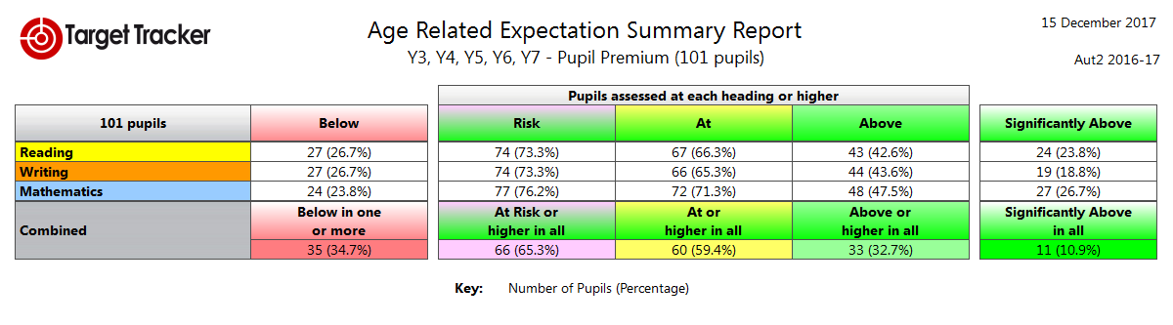

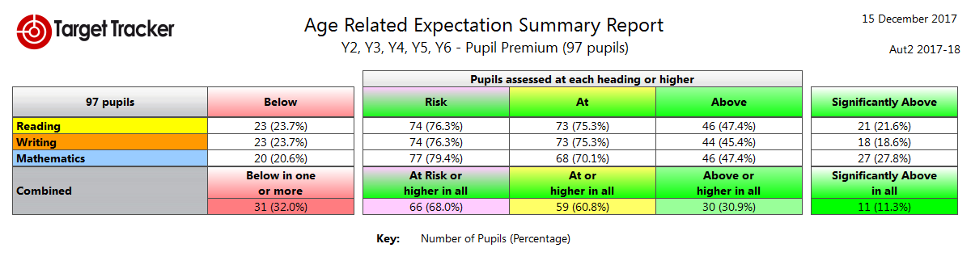

Provision of two additional experienced teaching assistants to support small group and individual interventions in Year 1. | To improve outcomes for targeted pupils in Y1 in Reading and Phonics | £26 628 | Year 1 Phonics – This year Y1 PP pupils were well above all pupils nationally (93.8% compared to 81%).  In Y2 PP pupils were below all pupils nationally (82.4% compared to 92%).  PP children were significantly above Non PP  KS1 - Attainment for PP pupils in Reading and Writing was slightly below Non PP children at the end of KS1 but above in Maths.  In Reading, Teacher Assessment judged 64.7% PP pupils at the Expected Standard. In the test, they achieved an average scaled score of 96.6 compared to Non PP pupils whose average was 99.5.  In Writing, Teacher Assessment judged 47.1% of PP pupils at the Expected Standard compared to 64.8% for Non PP pupils.  In Mathematics, 76.5% of PP achieved the Expected Standard or Exceeded compared to 73.2% of Non PP pupils.
  PP Age Related | Non PP Age Related
  93.8% | 81%
HLTA working solely delivering Intervention Programmes in Year 1 and Year 2. | To plan and deliver targeted support to vulnerable groups in Y1 and Y2. | £12 857
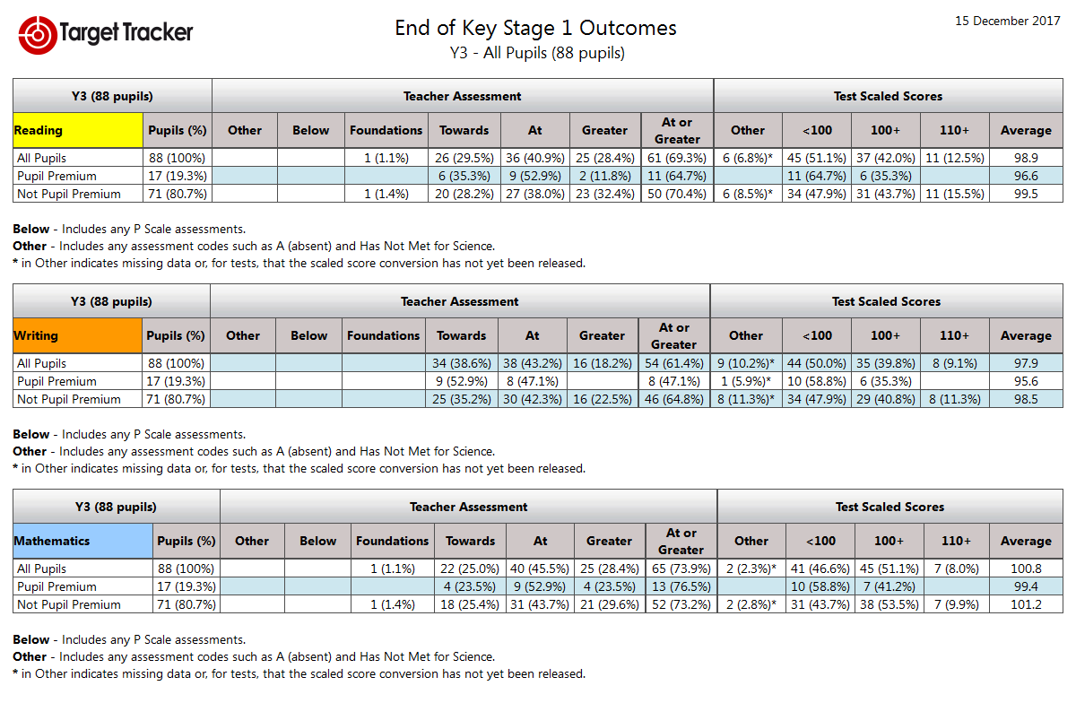
Talk Boost - additional TA provision to deliver intervention programmes | To improve speech and language of targeted pupils in EYFS to enable them to access the curriculum. | £7 890 | Progress and outcomes for PP pupils at the end of EYFS was less than for Non PP pupils in all AOLs. This is a cohort specific position for 16/17.
Additional TA to support pupils across EYFS whose language and communication skills are proving a barrier to progress. | To improve speech and language of targeted pupils in EYFS and Y1 to enable them to access the curriculum. | £7 890
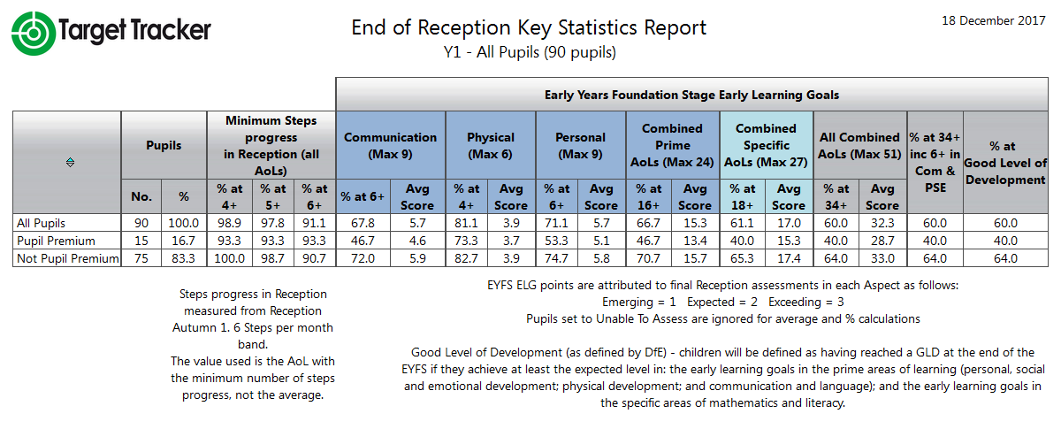

Attendance Officer Support | To improve school attendance in accordance with national benchmarks and ensure pupils are accessing learning regularly and on time. | £200 | Attendance figures for 2016/17 demonstrate that attendance of PP children (95.1%) was broadly in-line with Non PP children (95.9%) and national benchmarks.
   | PP | NPP
  R | 91.4% | 94.4%
  Y1 | 96.5% | 95.6%
  Y2 | 95.1% | 95.8%
  Y3 | 96.7% | 96.5%
  Y4 | 94.7% | 95.7%
  Y5 | 95.1% | 96.5%
  Y6 | 95.9% | 96.7%
Release time for SENCo | To monitor intervention and outcomes of targeted groups and provide support to teachers and support staff. | £10 572 | A review of tracking procedures has been undertaken and as a result whole school processes for targeting and supporting vulnerable learners was introduced in September 16.
Extra-Curricular Activities | To enable all pupils to access high quality educational opportunities beyond the classroom. | £1 000 | Funding has been made available to support PP children to attend extra- curricular activities and after school clubs. These experiences have a significant impact on the social skills, self-esteem and confidence of our children and this has a positive impact on learning in the classroom.
Bungalow Project Intervention | To support pupils with social, emotional and behavioural difficulties. | £6 000 | Children supported by the Bungalow Project, Educational Psychologist, Learning Mentor and PSA have benefitted significantly and are able to access learning more successfully. Parents have also been more engaged which has had a positive impact on behaviour and emotional well-being of pupils.
Additional Educational Psychologist Input | To support pupils, parents and teachers with strategies to enable the pupils to more effectively engage in their learning. | £2 700
Learning Mentor/PSA Intervention | To support pupils and their parents to engage in school and successfully access learning. | £10 785

Early Years Pupil Premium 2016/17

Number of pupils and Early Years Pupil Premium Grant allocation 16/17
Total number of pupils eligible for EYPP | 10
Amount of EYPP received per pupil | £340
Total amount of EYPP funding received | £3 400

Item/Project | Objective | Cost | Outcomes 16/17
Additional Teaching Assistant to deliver intervention programmes with targeted pupils. | To improve speech and communication skills of targeted pupils in Nursery to enable them to access learning.  To develop early Personal and Social skills to enable targeted pupils to access learning. | £4 051 | 93% of EYPP children made 6 steps or more progress in all AOLs (6 steps is the expected progress in all Areas of Learning during a year.)  Although all EYPP pupils were still below age expectation at the start of Reception, they made expected progress from low starting points.

2017/18
Allocation of Pupil Premium
The following outlines indicative Pupil Premium for the financial year 17/18.

Number of pupils and Pupil Premium Grant allocation 2017/18
Total number of pupils on roll (Reception-Y6) | 630
Total number of pupils eligible for PP | 100
Amount of PP received per pupil | £1 320
Total amount of PP funding received | £132 000

Item/Project | Objective | Cost | Outcomes 17/18
Two additional 0.6 teachers to teach a fourth set in Y2 and KS2 ensuring lower pupil numbers in each set | To provide higher staffing ratios in order to achieve improved outcomes for targeted pupils. | £57 701
Strategic Leadership of PP Outcomes | Co-HTs/TLRs Standards and Progress to track, monitor and evaluate strategies to maximise outcomes for PP children. | £12 500
Provision of teaching assistant support to provide small group and individual interventions in KS1. | To improve outcomes for targeted pupils in KS1. | £13 500
TA to support pupils across EYFS whose language and communication skills are proving a barrier to progress. | To plan and deliver targeted support to vulnerable groups in EYFS. | £7 000
HLTA to deliver intervention programmes in KS2. | To plan and deliver targeted support to vulnerable groups in Y4. | £4 500
Attendance Officer Support | To improve school attendance in accordance with national benchmarks and ensure pupils are accessing learning regularly and on time. | £1 000
Release time for SENCo | To monitor intervention and outcomes of targeted groups and provide support to teachers and support staff. | £11 000
Extra-Curricular Activities | To enable all pupils to access high quality educational opportunities beyond the classroom. | £1 000
Bungalow Project Intervention | To support pupils with social, emotional and behavioural difficulties. | £6 000
Additional Educational Psychologist Input | To support pupils, parents and teachers with strategies to enable the pupils to more effectively engage in their learning. | £2 700
Learning Mentor/PSA Intervention | To support pupils and their parents to engage in school and successfully access learning. | £10 785

