Nursery Curriculum Overview

Spring Term 2 – Bear Necessities
Daily Phonics, stories, songs and rhymes.  Topic Related Stories:  Goldilocks and the Three Bears  We’re Going on a Bear Hunt  Brown Bear Brown Bear what do you hear?  Polar Bear Polar Bear What do you see?  Monkey Puzzle  Peace at last  Whatever Next  Just one of those days  The Everywhere Bear  This is the Bear- Various stories  My Mum is Fantastic  Maths:  Length/ Height  Weight  Pattern  Special Events  Shrove Tuesday  Mothering Sunday | 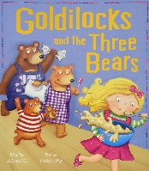  What type of Bears are in the stories?  - Goldilocks and the Three Bears  - Making porridge/ pancakes  - Ordering items by size  - Using role play to act out the story.  - Create a crime scene  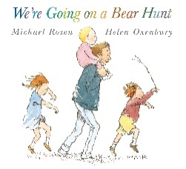  - Was it a good thing to do to enter a house like that?  - What do we want to know about bears?  - Creating a sensory bear hunt.  - Adding music to the story  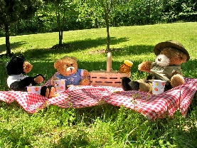  Where would you take your teddy bear for a picnic?  - When you go down to the woods today song  - Bedtime story day – Dressed in pyjamas. Read your teddy a story and enjoy a Teddy Bears picnic  - Sensory Bear Hunt    Why are Mums special?  - Discuss the special ladies in our lives.  - Why do they make us happy?  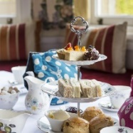  - Making special gifts for our special ladies  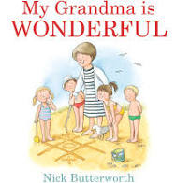  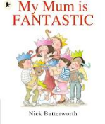  What facts do I want to know about bears?    We will be taking the lead from the children and finding out lots of interesting facts based on what the children’s interests are.  - Create habitats for Polar Bears, Grizzly Bears and Panda Bears  - Compare the sizes of bears and their features  - Taste bear food and create a pictogram of our favourites

