Reception Curriculum Overview



Autumn Term 2 – Dinosaur Discovery

Daily Phonics  Topic related stories:  Harry and the Dinosaurs Series  How do Dinosaurs..? Series  Dippy’s Sleepover  Tyrannosaurus Drip  Dinosaur Zoom  Dinosaur’s Day Out  See inside the World of Dinosaurs  Talk 4 Writing: Dinosaur Roar  Storytelling with props  Oral rehearsal  Adding actions to story  Story maps  Sequencing  Related art work  Drama activities  Independent Writing  Mathematics:  Comparing 1,2,3  Composition of 1,2,3  Circles and triangles.  Positional Language  Shapes with 4 sides  1 more 1 less  Time Night and Day  Special Events  Bonfire Night  Remembrance Sunday  Diwali  St Andrews Day | Dinosaur Roar  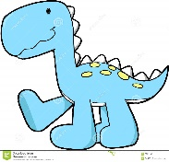  - Developing painting techniques/Bonfire pictures  - Dinosaur movement – big movement in outdoor area  - Fiction/Non Fiction Dinosaurs  - Multi skills PE session delivered by MFC  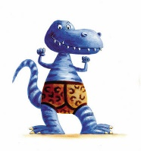  Dinosaurs Love Underpants  - Making Poppies for Remembrance Sunday  - Multi skills PE session delivered by MFC  - Thinking of adjectives in the story  - Painting Underpants  Bumpus, Jumpus, Dinosaurumpus  - Making predictions – What is in the Egg?  - Use marbling ink to make a dinosaur egg.    - Dino Dig  - Investigate melting ice eggs with water  - Multi skills PE session delivered by MFC  - Making Christmas cards ready for the display  Stomp, Chomp Here Come the Dinosaurs  - Writing descriptive sentences  - Inventing dinosaur dances with a partner.  - Using percussion instruments to create music for a story.  - Investigating dinosaur poo to discover if the dinosaur is herbivore or carnivore or omnivore  - Multi skills PE session delivered by MFC  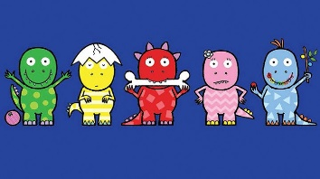  10 Little Dinosaurs  - Researching facts to create a fact file  - Multi skills PE session delivered by MFC  - Investigating melting/freezing    The Christmas Story  - Making calendars  - Decorating Christmas bags  - Making Christmas decorations  - Letters to Santa  - Christmas party  - Pantomime trip to MLT

