Reception Curriculum Overview

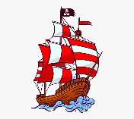
Summer Term 1 – Shiver My Timbers

Daily Phonics  Topic related stories:  A New Home for a Pirate.  The Night Pirates  My Granny is a Pirate  Ten Little Pirates  Pirate House Swap  Captain Pike Looks After the Baby  Mrs Pirate  The Pirate Cruncher  Tim, Ted and the Pirates  Shiver me Timbers  Captain Flinn and the Pirate Dinosaurs  Talk 4 Writing: Peace at Last  Storytelling with props  Oral rehearsal  Adding actions to story  Story maps  Sequencing  Related art work  Drama activities  Independent Writing  Mathematics:  Building Numbers beyond 10  Counting patterns beyond 10  Spatial reasoning  Adding more  Taking away  Special Occasions:  Ramadan  St Georges Day  Eid Ul Fitr  May Day | 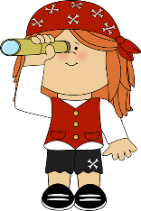  Pirates love underpants  - Making a whole class mind map  - Role play area – pirate school/pirate ship  - Make giant collaged flag and individual small flags.  - Pirate games  - Independent recount writing  - Build pirate boats using 3D shapes  - Make treasure chests and salt dough treasure over the half term  (paint shoe box/shredded tissue/painted salt dough treasure).  The Troll  - Paper plate pirate  - I spy games  - What I like to eat/what a pirate likes to eat  - Making playdough pirates  - Make class book using homework on different types of boats.  - Paint a pirate  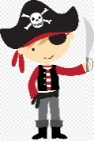  - Pirate mask.  - Make treasure chests  - Pirate Bunting red/white with black felt tip pen  - Ice melting/freezing experiment.  - Salt water/fresh water discussion and tasting.  - Make a bottle of magical sea water  Yo, Ho, Ho, A-Pirating we will go.  - Make a telescope.  - Observational drawing of a parrot  - Hand print parrots.  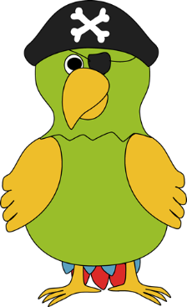  - Get Squiggling- step by step drawing of a pirate  - Make a collaborative large scale 3D treasure map of a pirate island  - How do you make a Pirate float?  Pirate Pete  - Message in a bottle.  - Bandana/ Hats/ Masks/ Hook  Investigating the best material to make a boat  The Pirates Next Door  - Design and make pirate jewellery  - Sort treasure into hoops- shiny/dull/magnetic/non magnetic  - Paint stones silver/gold/bronze for pirate treasure  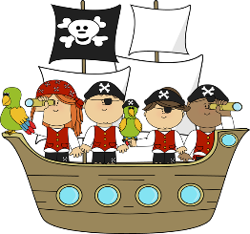  - Make coins out of salt dough.  - Outdoor treasure hunt to find gold coins.  - Hook a duck  - Making and tasting pirate food  - Pirate party

