Reception Curriculum Overview

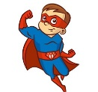

Spring Term 2 –Superheroes
Daily Phonics  Topic related stories:  My Dad is a Superhero  Nat Fantastic  Eliot Midnight Superhero  Super Me  Superhero School  Talk 4 Writing: Whatever Next  Storytelling with props  Oral rehearsal  Adding actions to story  Story maps  Sequencing  Related art work  Drama activities  Independent Writing  Mathematics:  Ordering numerals to 10  Number bonds to 10  3D Shape  Pattern  Special Events:  St David’s Day  Mother’s Day  St Patrick Day  World Book Day  Comic Relief |   Super Daisy  - Mind map- Superheroes  - My super power is …  - Paint a superhero  - Investigation- What is a superfood?  - Making Super Slime  Supertato  - Design own super hero  - Vintage Superheroes – watch clips  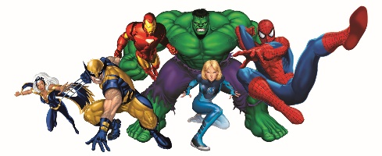  - Writing superhero profile  - Real life superheroes- Police  Superworm  - Testing surfaces for a super vehicle  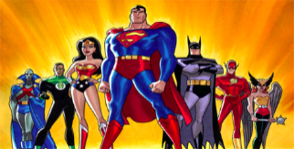  - Mother’s Day- why is my Mum fantastic  - Make Mother’s Day cards  - Real life superheroes- (Family)  Superkid  - Build a junk model super vehicle, think of words to describe it  - Investigate the best materials for making a cape  - Real life superheroes- NHS  - Make a superhero biscuit  How to be a Superhero/Whatever Next  - How to be a Superhero story  - Superhero obstacle course  - Making super healthy fruit smoothie    - Collaging superhero cuffs  - Easter cards  - Easter Nests

