Nursery Curriculum Overview

Summer Term 2 – Up the Boro!
Daily Phonics, stories, songs and rhymes.  Topic Related Stories:  Daddys Lullaby  My Dad is Brilliant  My Grandpa is Amazing  Dinosaurs Day Out  Once there were giants  Paper Dolls  When I grow up  You Choose  Train and transport stories  Maths:  Capacity  Shape  Positional Language  Special Events  Father’s Day- 19th June     | Why are Dads special?  For Father’s Day we will be talking about the special men in our lives and all the things they do to make us happy.  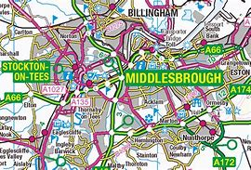  Where do we live?  We will be taking the lead from the children and  finding out lots of interesting facts about  our local area.  We will go on a ‘Let’s Investigate’ walk around  our school to find out what are people’s favourite  things about our local area.  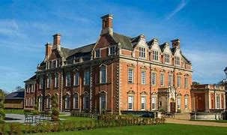  We will walk around the local vicinity and visit key  places near school.  What special places are in Middlesbrough?  We will be looking at landmarks in Middlesbrough  and asking the children to visit places with their family.  We will recreate some of the landmarks in our    Nursery ‘Little Lane’ town  Who are our local artists?  Our creative focus will be on local artists  - Lucy Pittaway – We will read stories in which sheep feature  - McKenzie Thorpe – We will read stories about our heart and emotions  - Bobzilla – We will look at stories and non-fiction books about species of birds  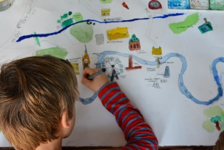  - John Durkin – We will look at Inspector Croc  MFC  We will be looking at MFC and finding out why Boro is important to local people. We will be having a go at playing football and learn new skills.  How can we look after or local area?  We will take part in a litter pick around the vicinity and within the school premises. We will look at the importance of recycling.  We will be making ‘OUR’ outdoor area look spectacular. We will be planting and looking after our garden.    Our Learning Journey so far  We will be talking about our time in Nursery. We will be thinking about what we have enjoyed, the friends we have made and what have we learned. We will be making some interesting items to remember our time in Nursery.  Preparing for Reception  During this half term we plan to visit Reception regularly to become familiar with the staff and the classrooms.

