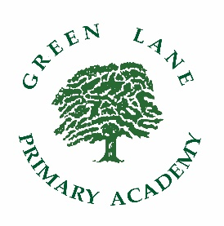

GREEN LANE PRIMARY ACADEMY

HLTA – Person Specification

Area | Essential | Desirable
Qualifications | - HLTA status or relevant qualifications e.g. Foundation Degree / Degree in Education (A)  - English and Maths qualifications equivalent to or exceeding GSCE A-C or Grade 4+ (A) | - Evidence of further professional development (A)
Experience | - Excellent practitioner based on recent experience/observations (within the last two years) (A, I, R)  - Substantial and recent experience of working with children across EYFS, KS1 and KS2 (A, I, R)  - Experience of working successfully and co-operatively as a member of a team (A, I, R)  - Experience of covering whole classes (A, I, R) | - Leading and managing other support staff  - Training or expertise in a relevant curriculum or other learning area (e.g. ICT, English or Maths)  - Working with children who have special educational needs/EAL  - Experience of working across the curriculum
Knowledge and Skills | - Knowledge and understanding of the National Curriculum and EYFS Framework  (A, I, R)  - Evidence of high calibre teaching assistant support (A, I, R)  - A range of classroom and behaviour management techniques (A, I, R)  - Willingness to become fully involved in all aspects of school life (A, I, R)  - Ability to communicate effectively in a variety of situations - both verbal and written (A, I, R)  - Demonstrate initiative and independence (A, I, R)  - Demonstrate the ability to work as part of a team (A, I, R)  - Ability to manage workload effectively (A, I, R)  - Evidence of having capacity to build and sustain effective working relationships with pupils, staff and parents (A, I, R)  - Understanding of the SEND Code of Practice and implications in a mainstream setting (A, I, R)  - Demonstrate understanding of safeguarding policies and legislation (A, I, R)
Additional Information  Safeguarding | - Enhanced safeguarding checks (A)  - Identity and qualification checks (I)  - Recent references (I)

A – Application Form I – Interview R - References

